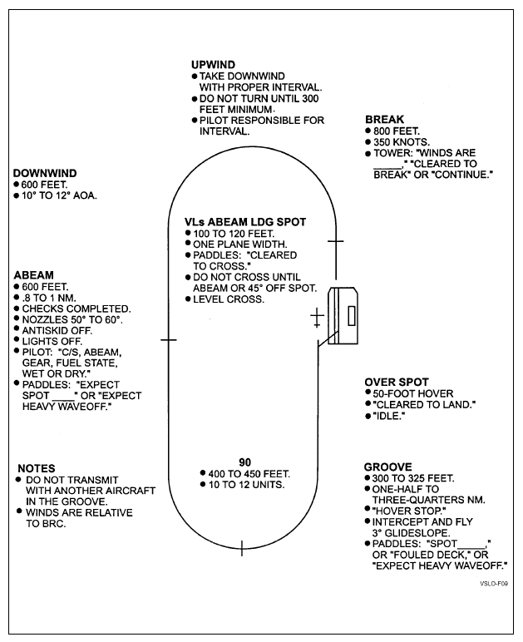

**LHA Day Case 1 Patterns**